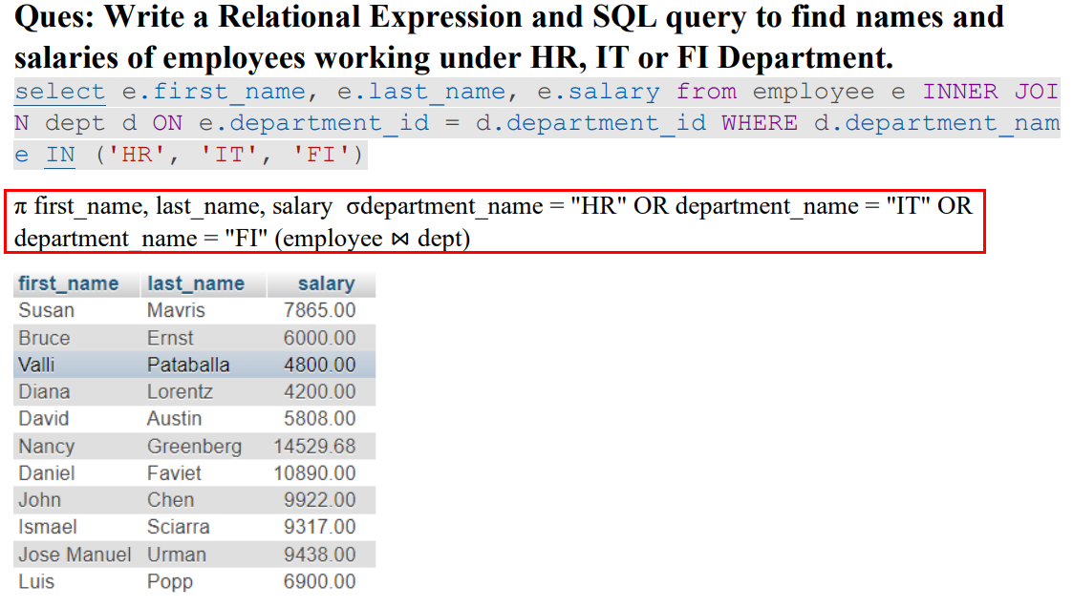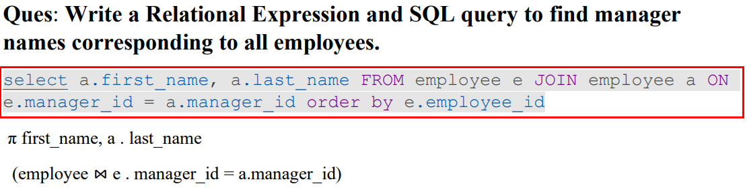

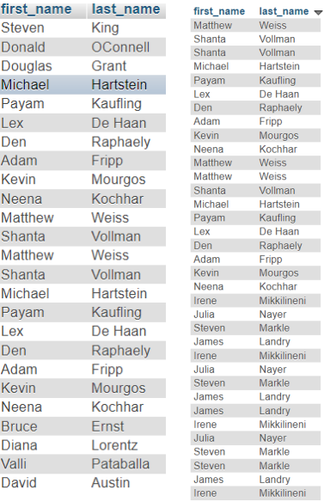

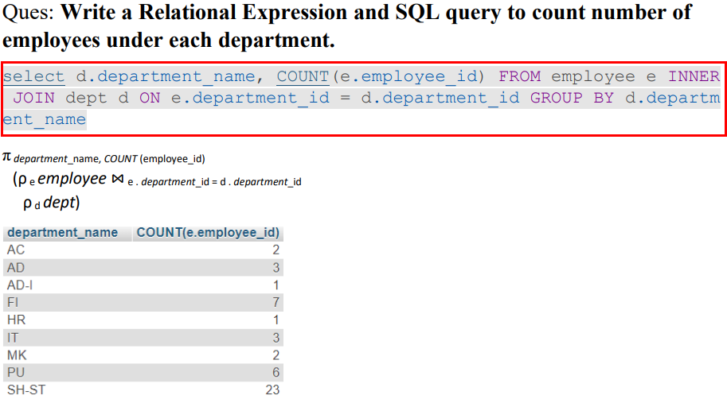

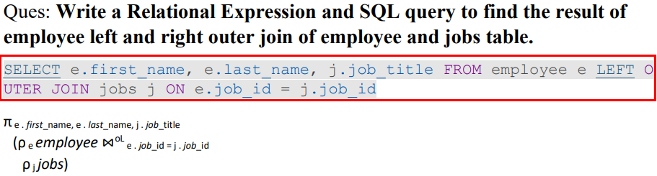

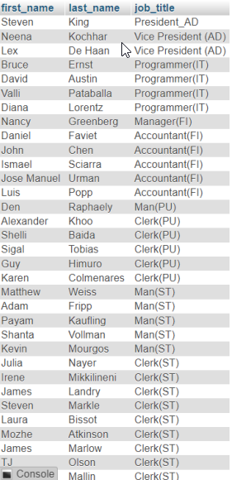

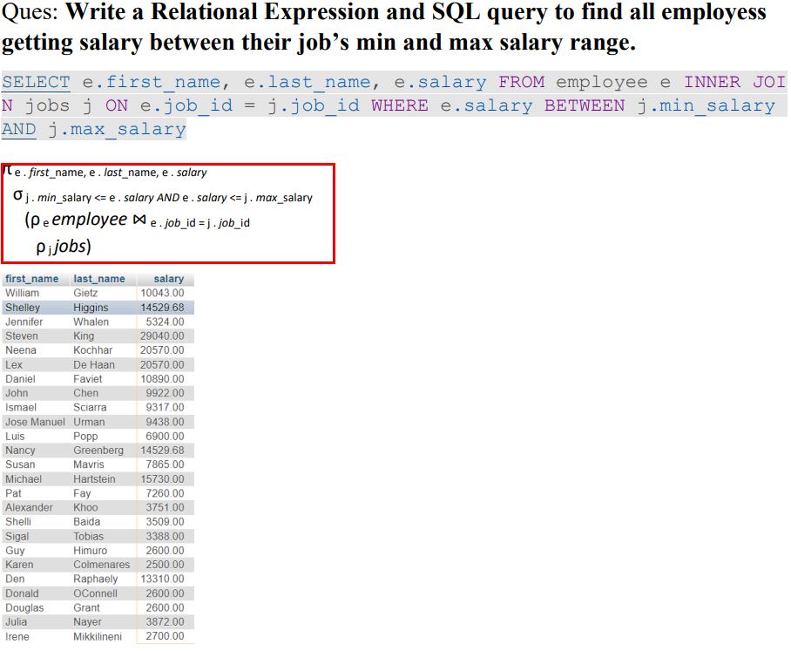

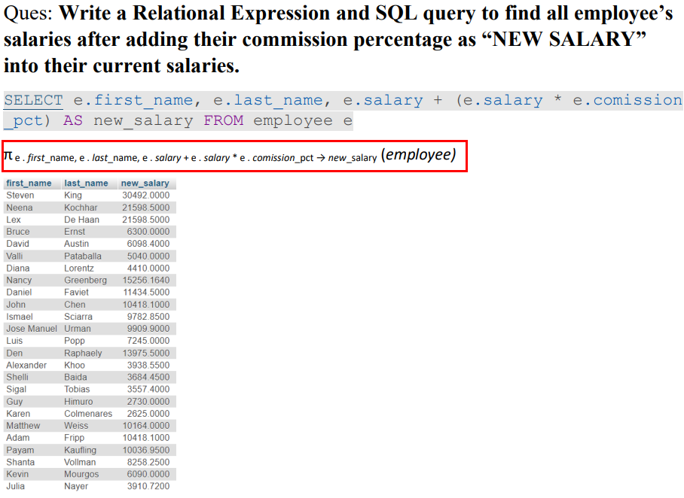

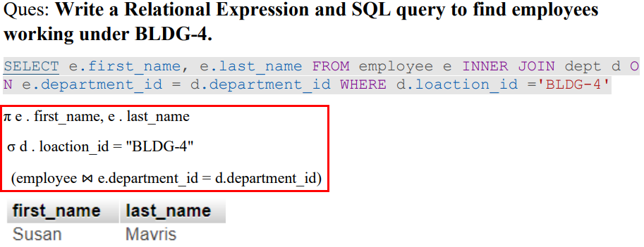

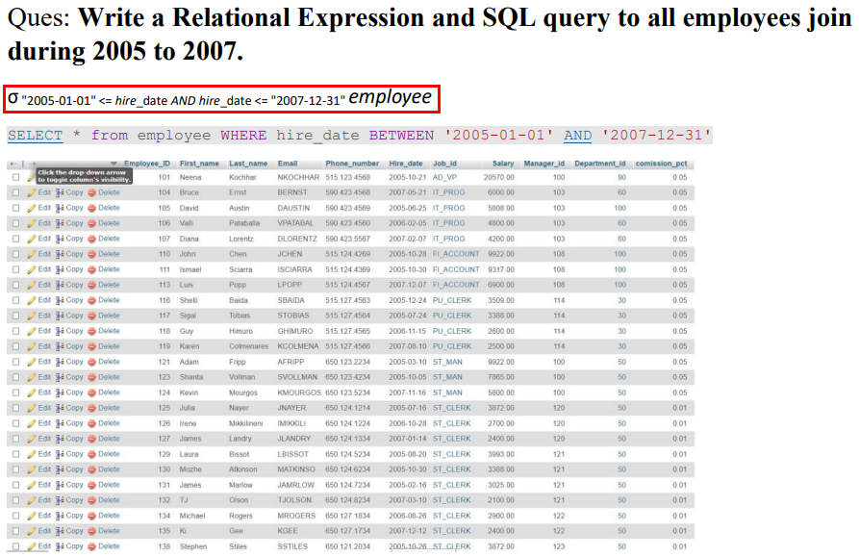

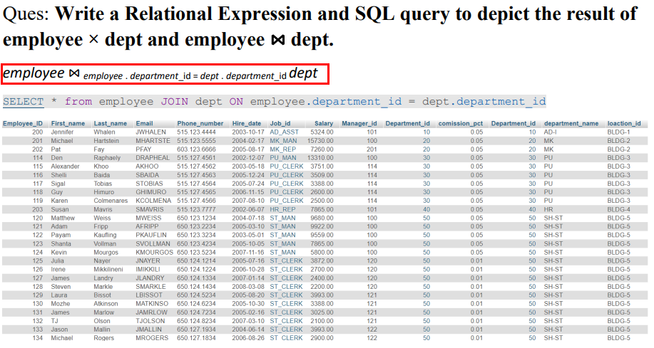

Practical--01

**Ques: Create a database with the name “Employee_Shruti”.**

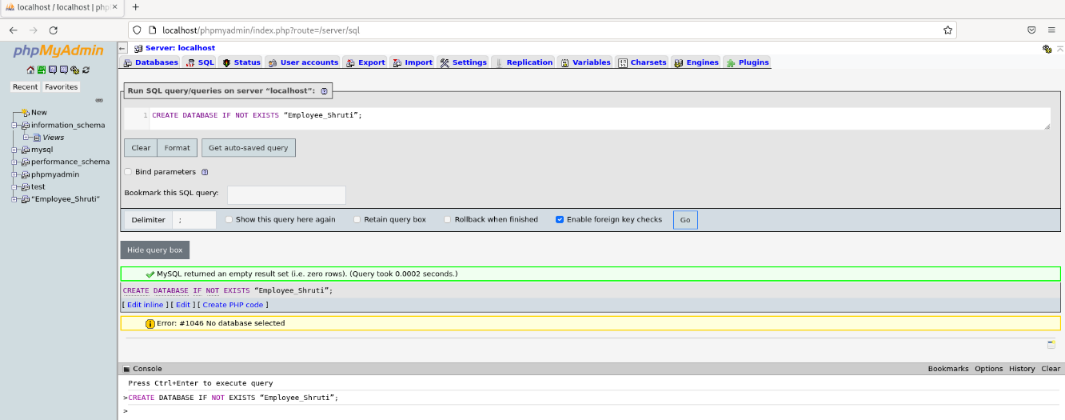  
**Ques: SQL Query to create employee table in Employee_Shruti Database.**

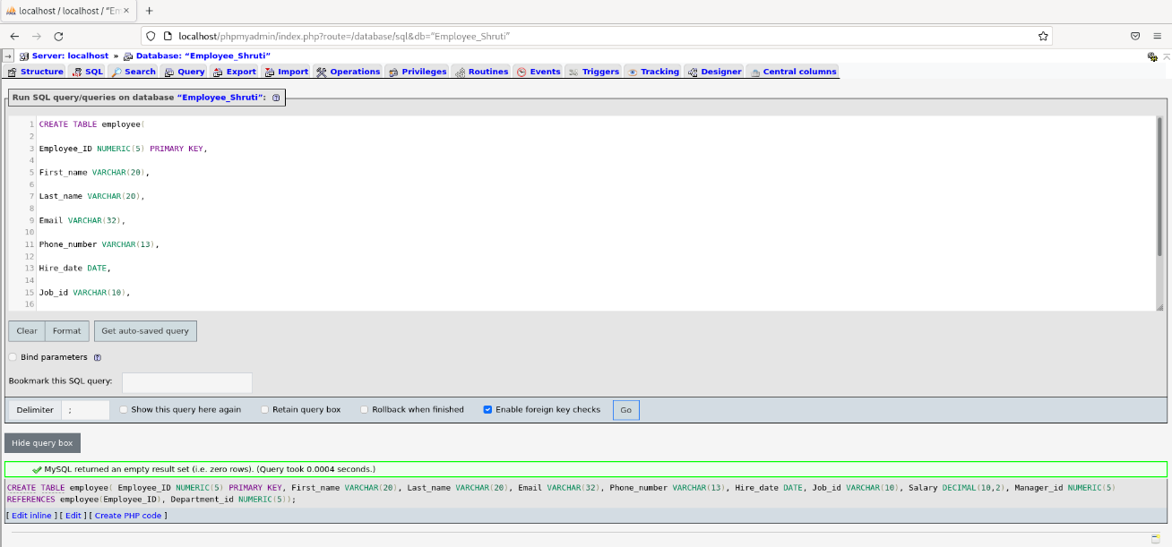

**Ques: SQL Query to Create Jobs Table in the Employee_Shruti Database.**

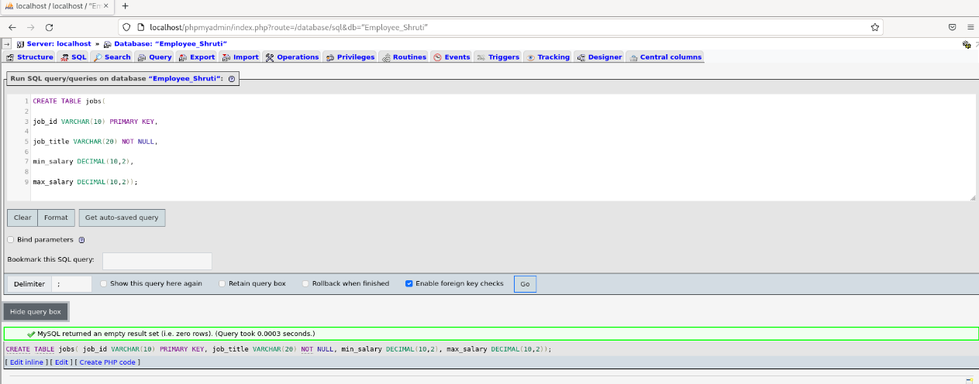

**Insert Record in Department.**

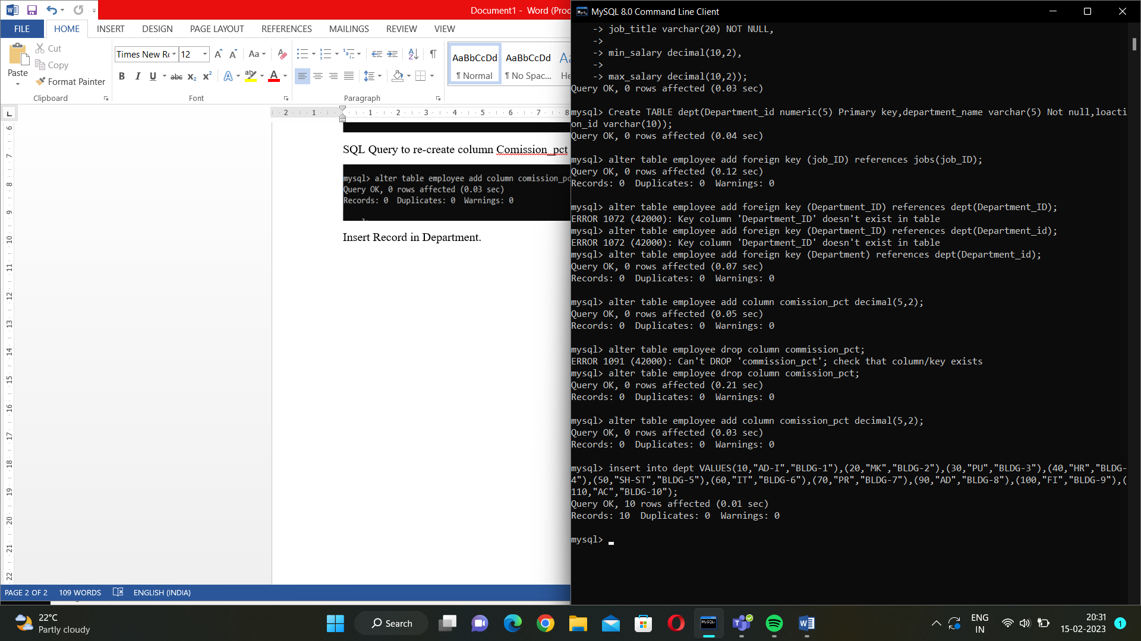

**Insert records into jobs table.**

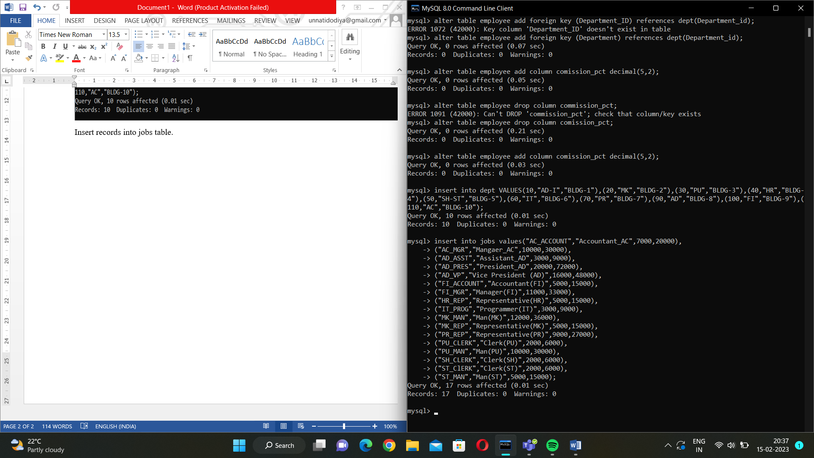

**Insert Record to employee Table.**

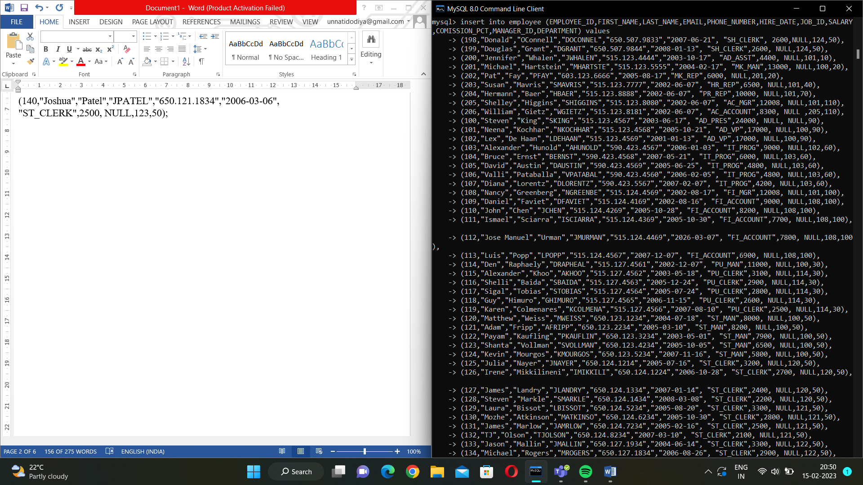

Practical-03

Find all employees works in SH-ST Department.

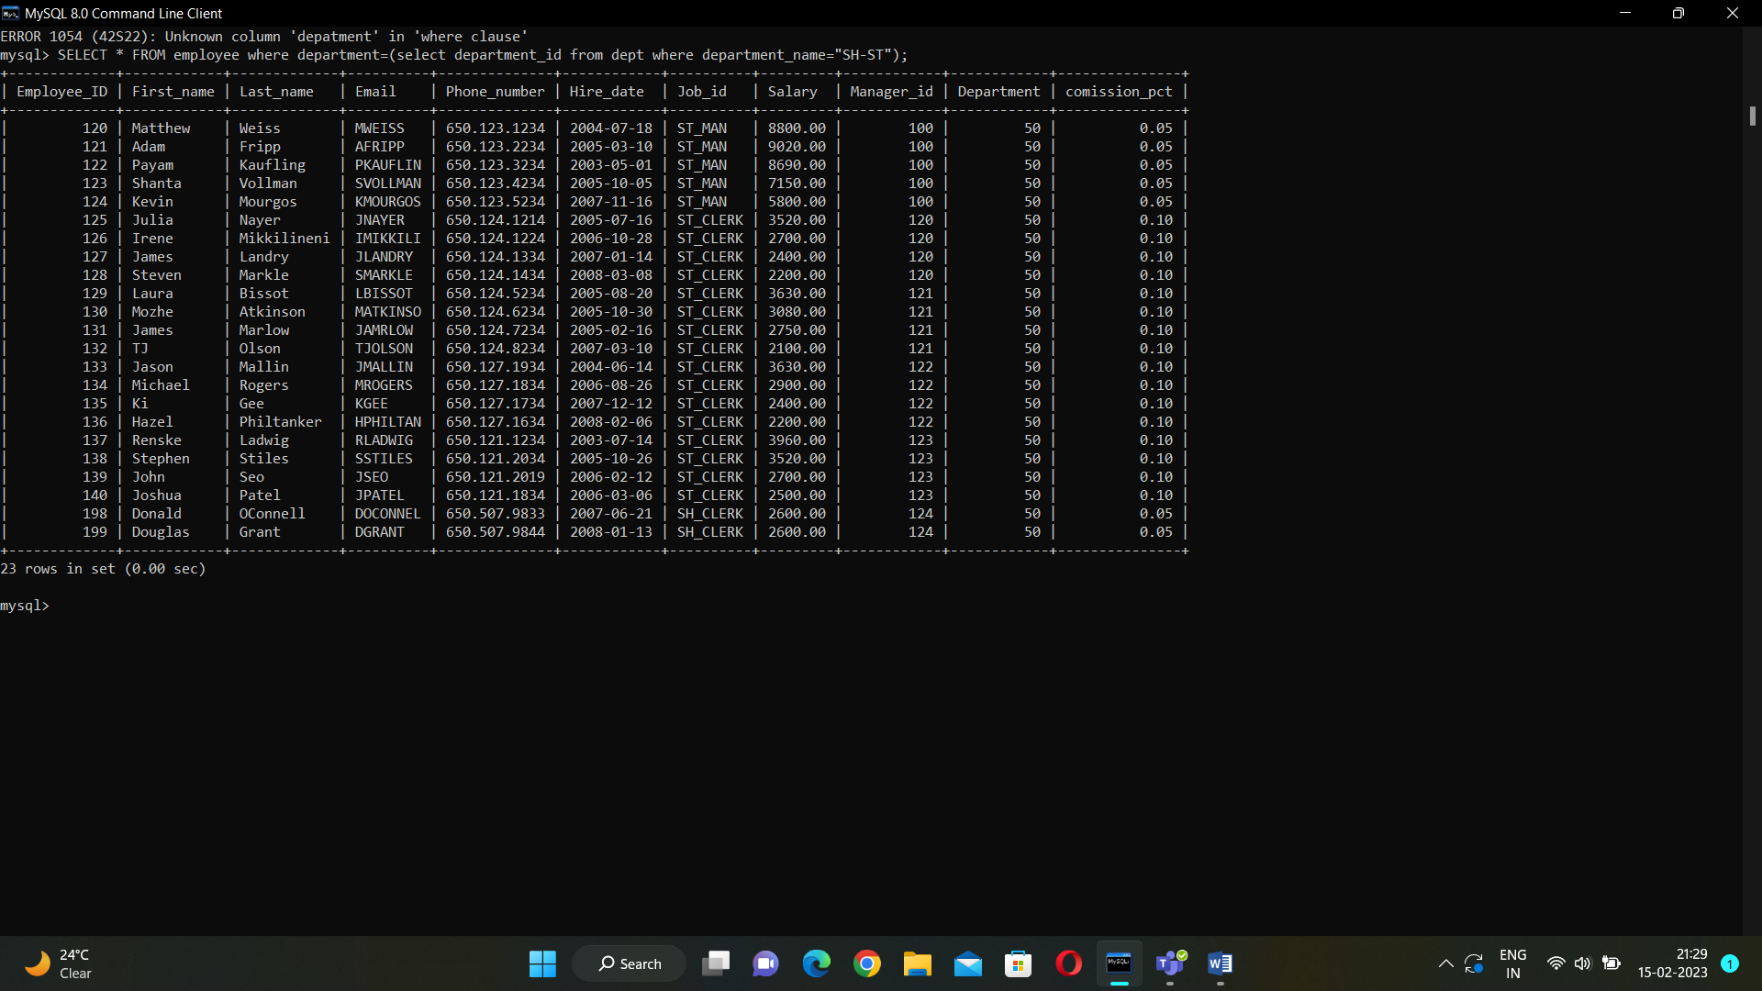

Find First name, email, and hire date of all employees who got hired after 01st Jan 2007.

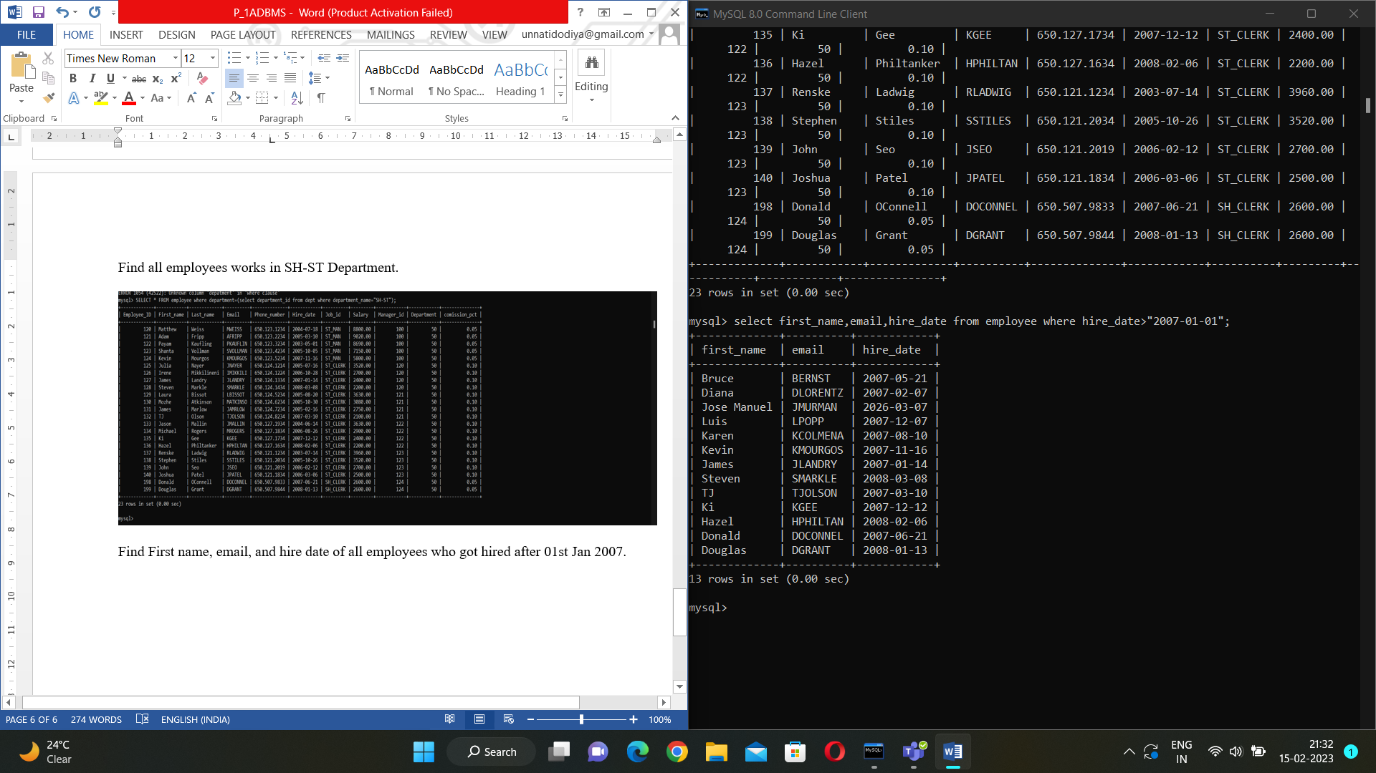

Find all employees work under PU Department and having salary more than 2000$.

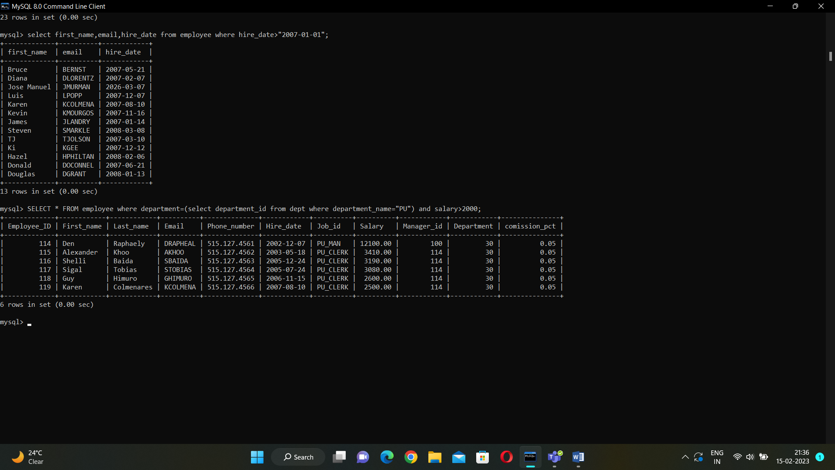

Find total salaries of all employees working under same department. (Hint: Group employees based on the department they work in).

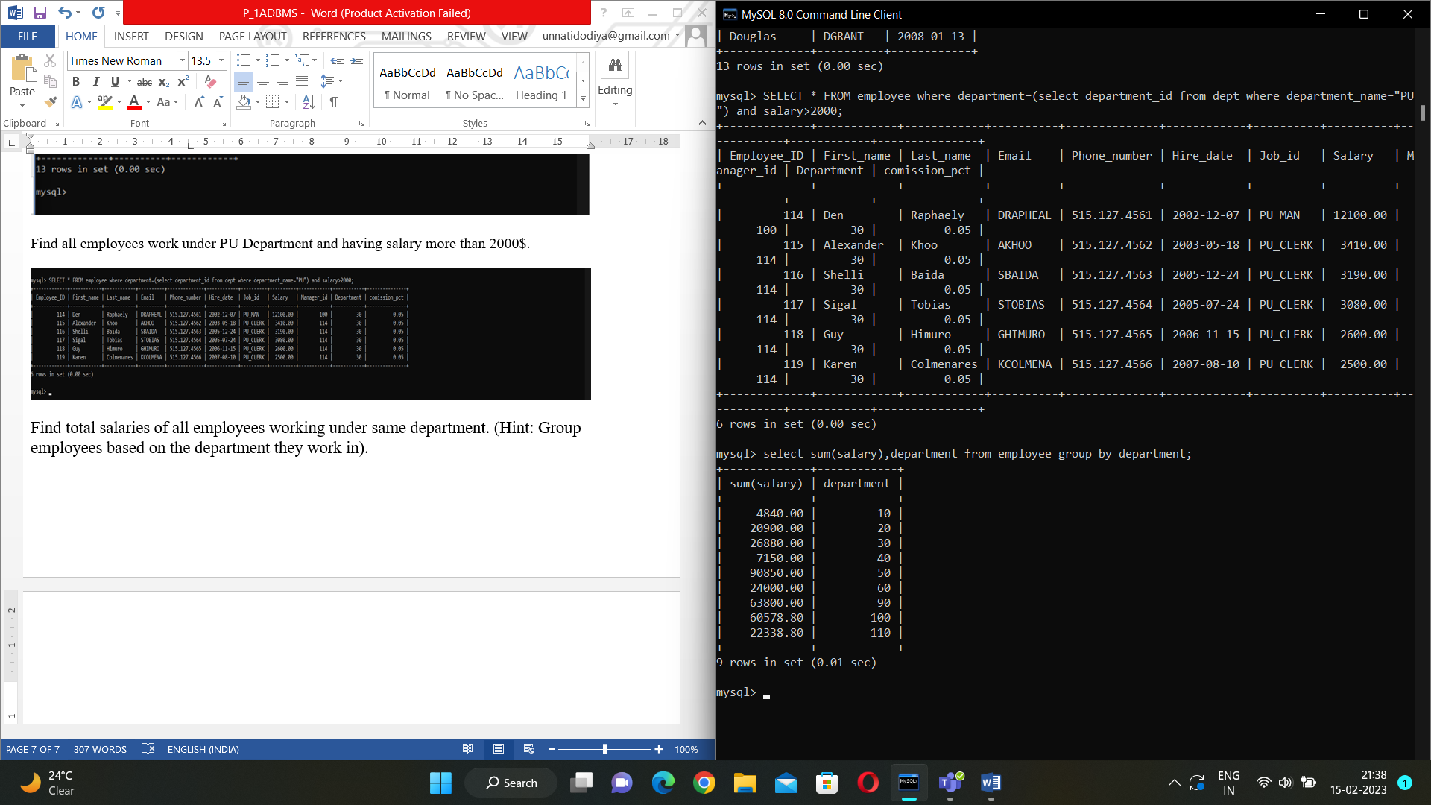

Find list of employees based on the ascending order of their tenure in the company.

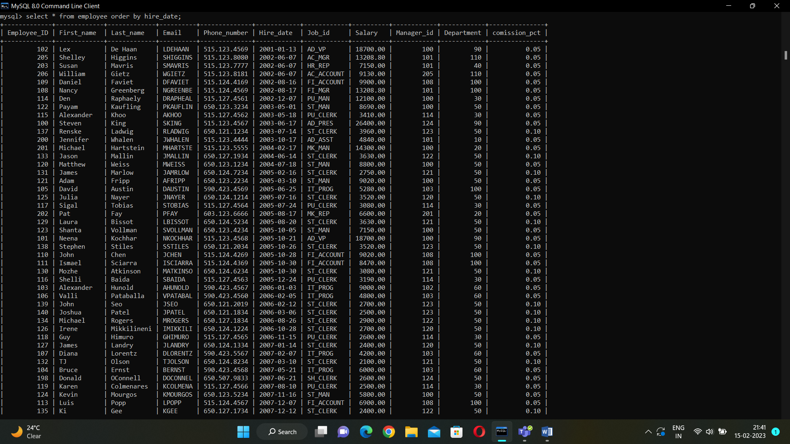

Find the list of employees based on the descending order of their Salaries.

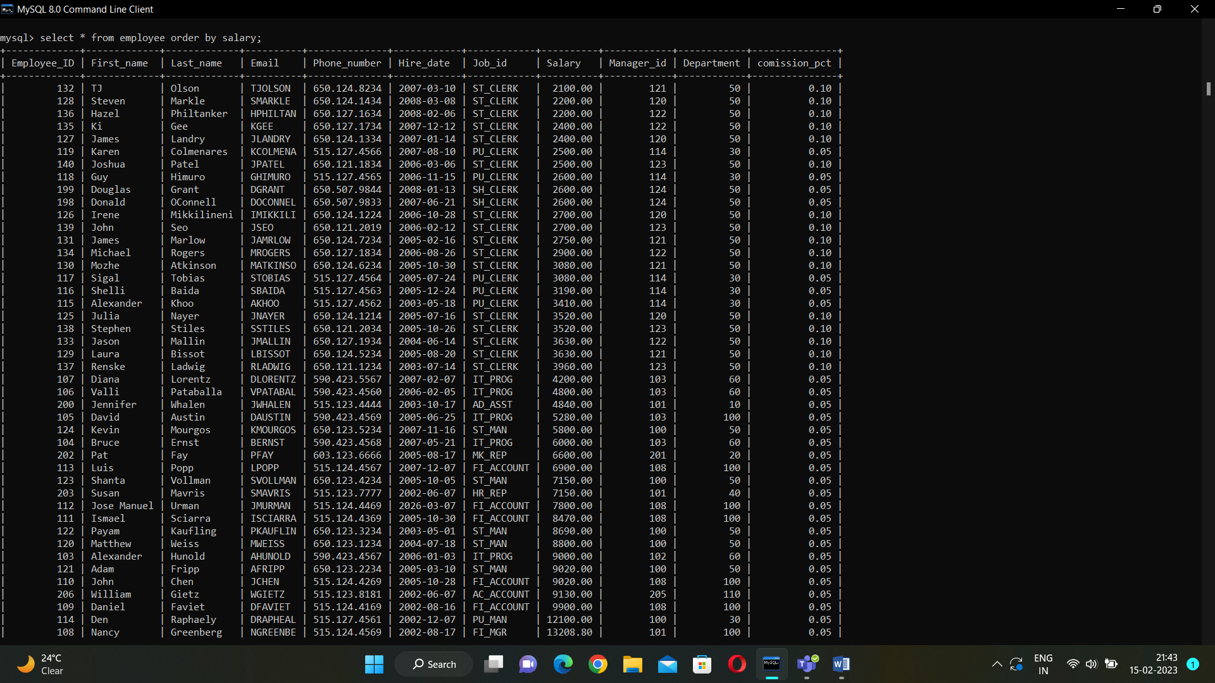

Find employee ID and First name of all employees work under HR, PU, IT and FI Department.

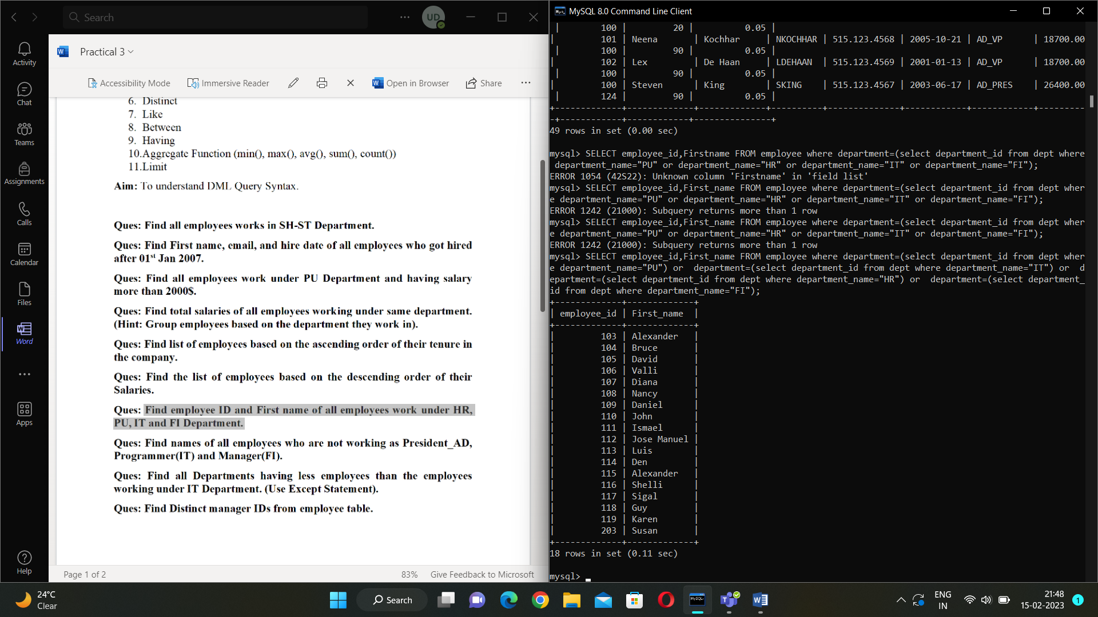

Find names of all employees who are not working as President_AD, Programmer(IT) and Manager(FI).

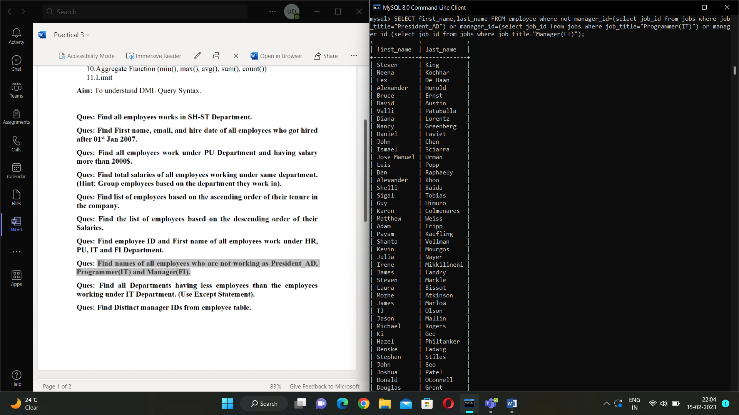

Find Distinct manager IDs from employee table.

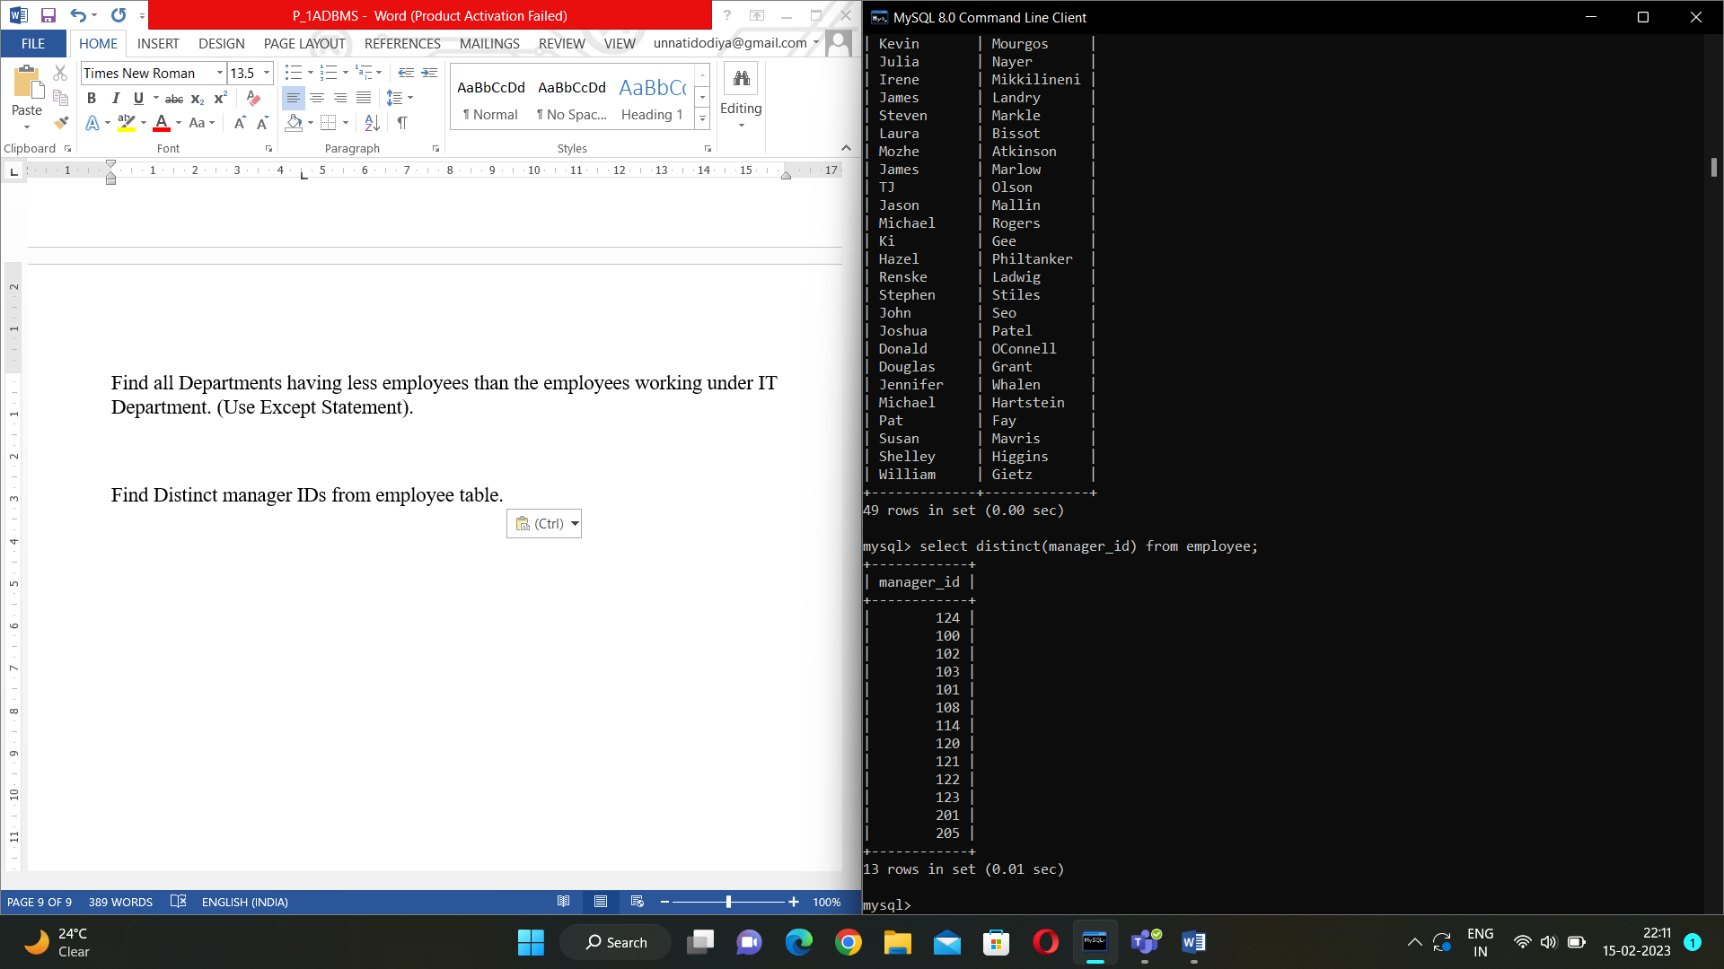

Find all employees having “nd” as a substring in their first name or in last name.

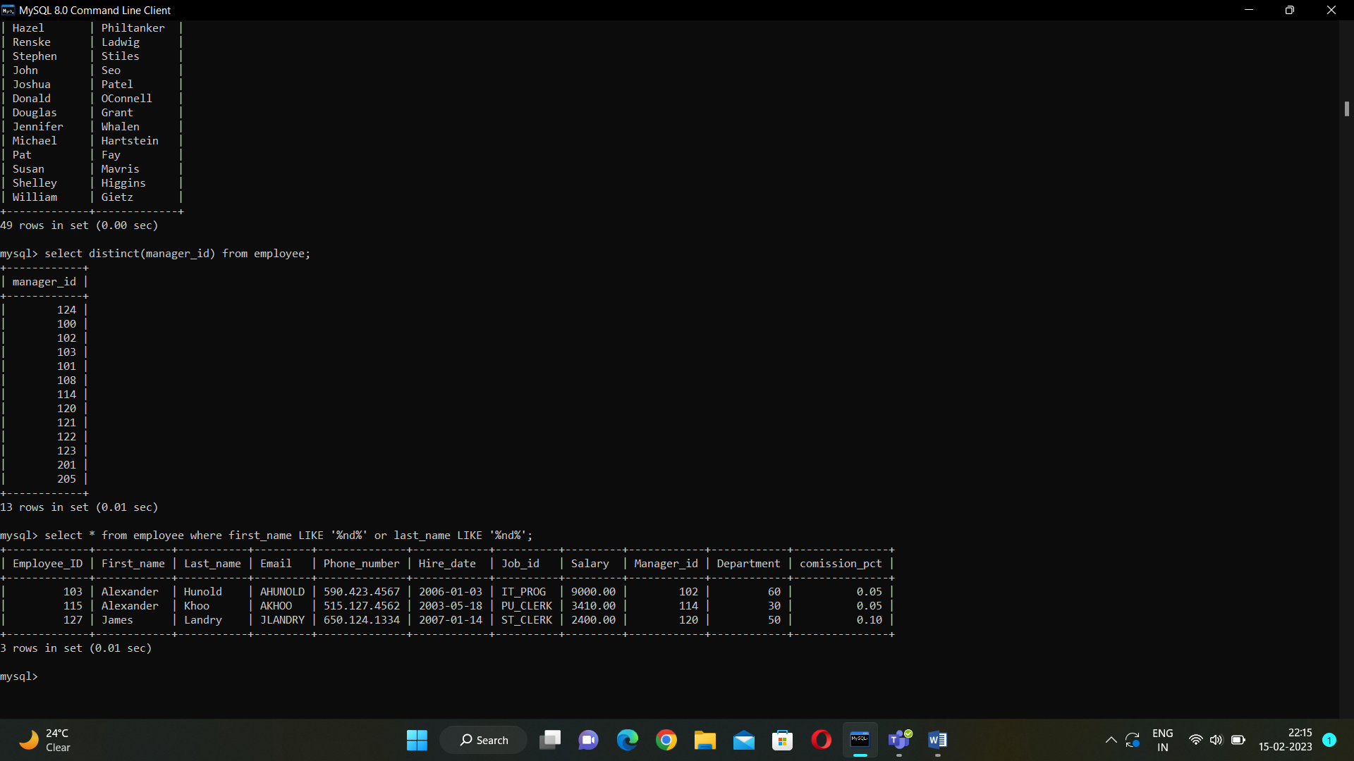

Find all employees joined between 2006 and 2008.

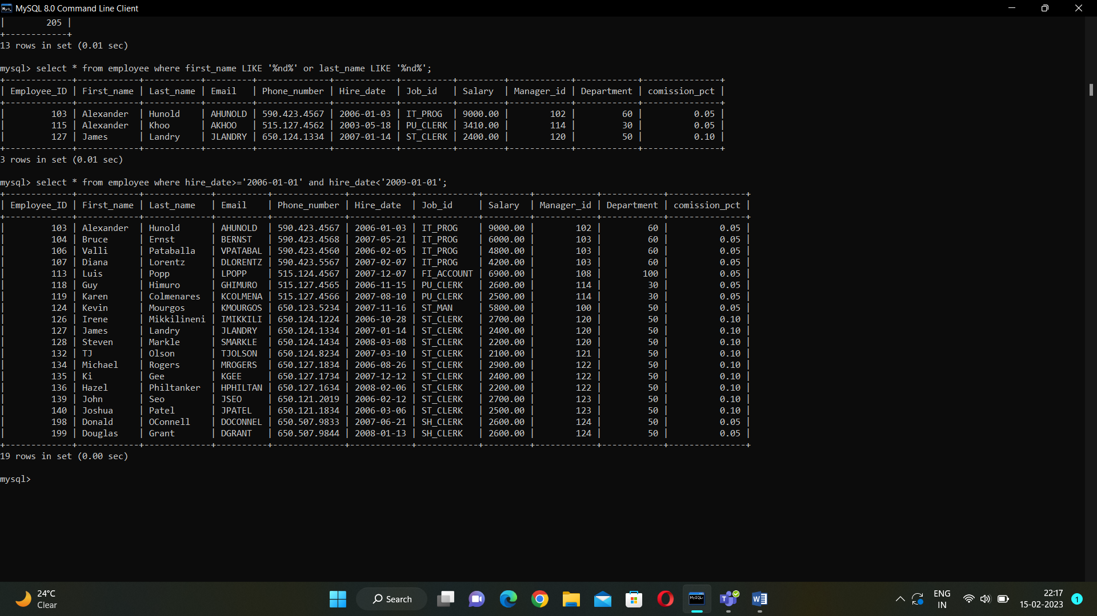

Find all employees having Nancy and Den as their Manager. (Use Having Clause).

Find the Highest and Lowest Salary drawn by any employees.

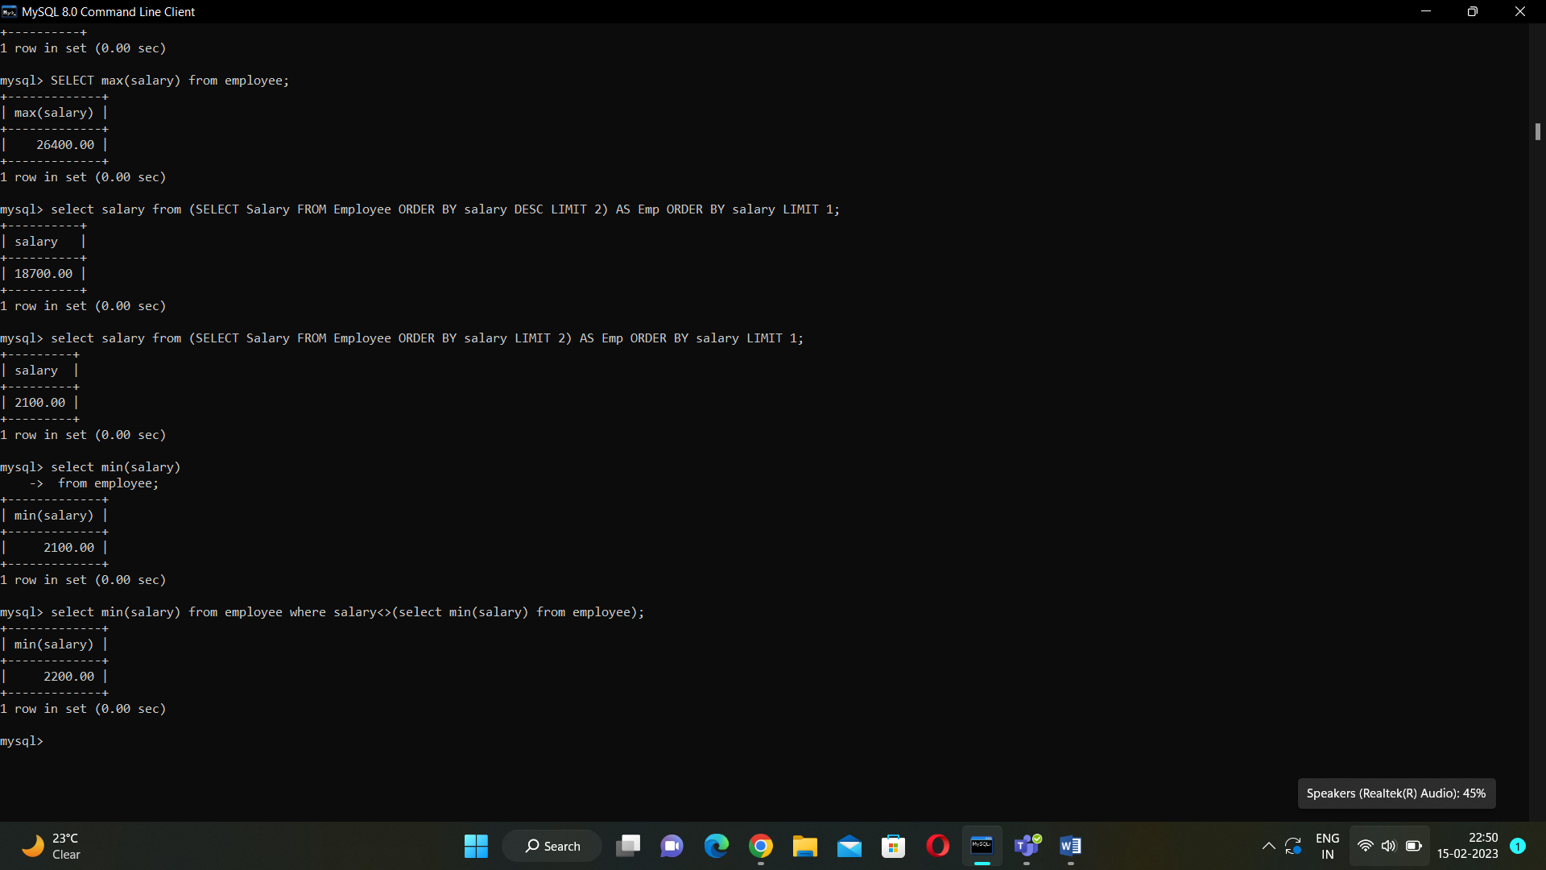

Count number of employees working under IT Department.

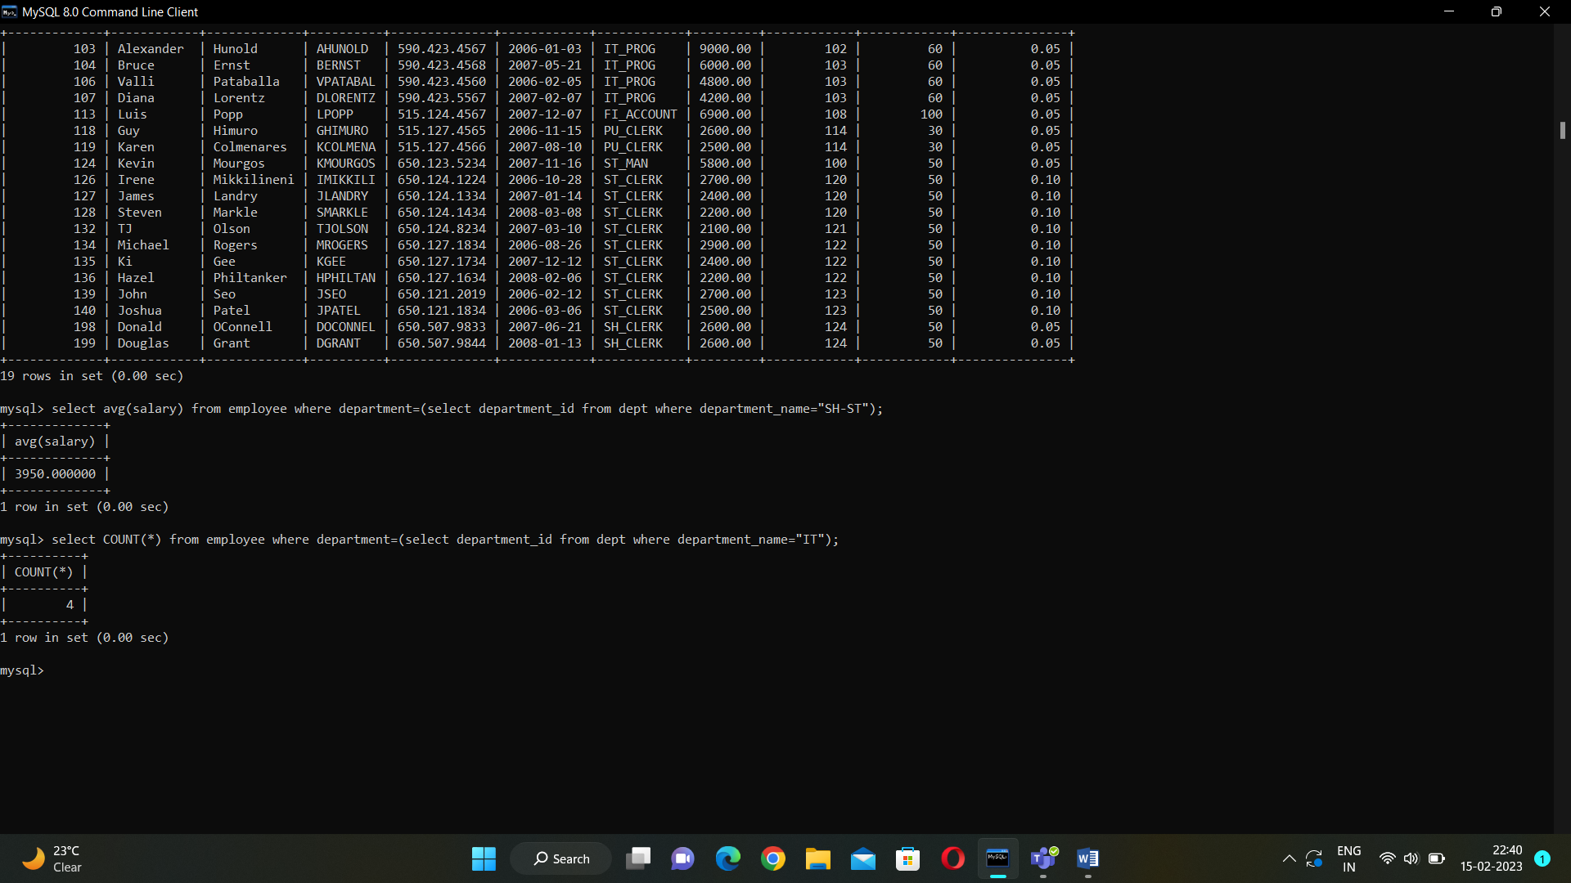

Find average salary of all employees working under SH-ST Department.

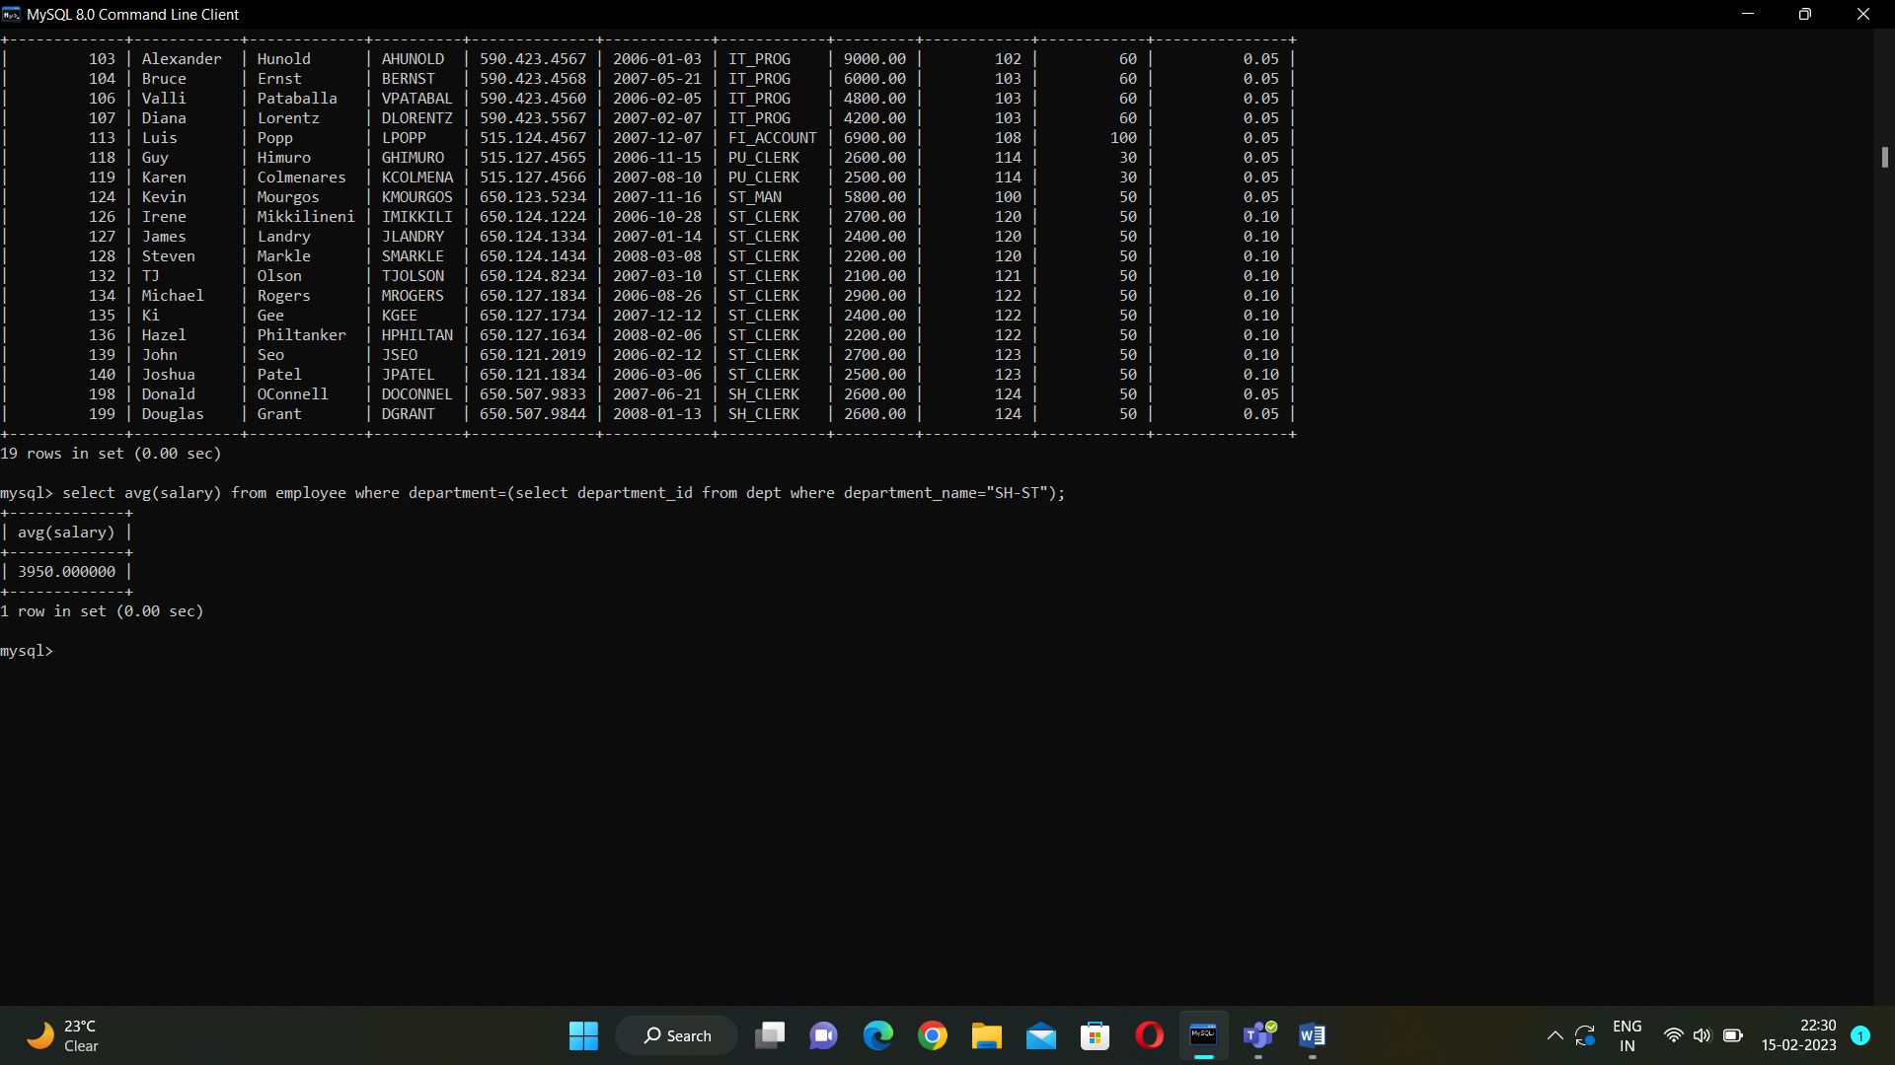

Find the name of employees getting Highest and Second Highest Salary. (Use Limit)

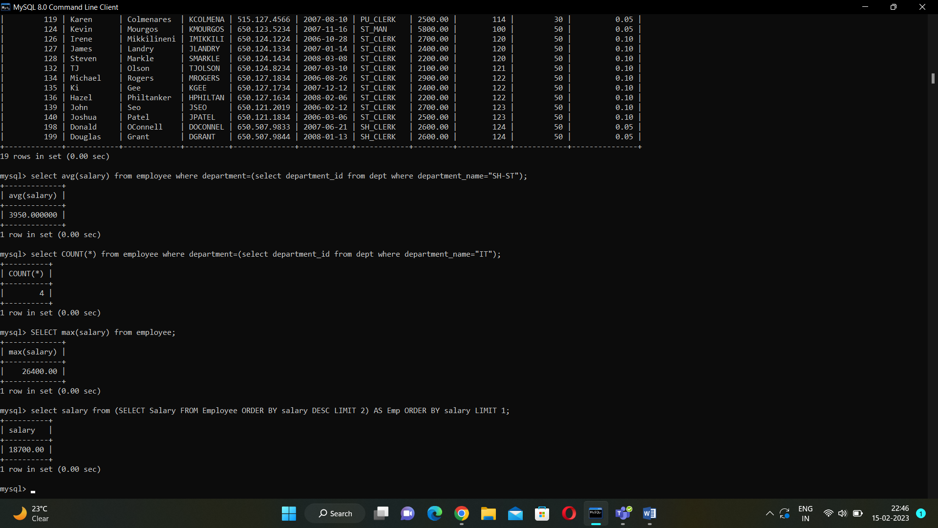

Practical-02

**Write an Update query to set 124 employee ID as Manger ID for Employee ID 100.**

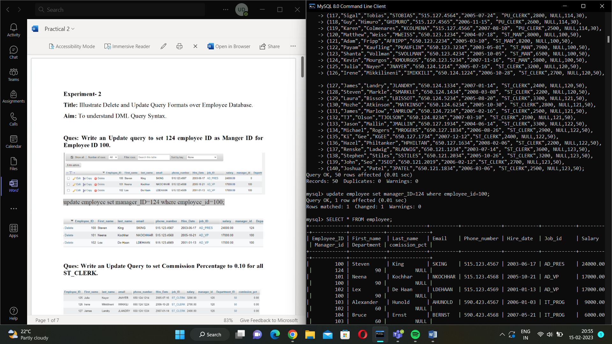

**Write an Update Query to set Commission Percentage to 0.10 for all ST_CLERK.**

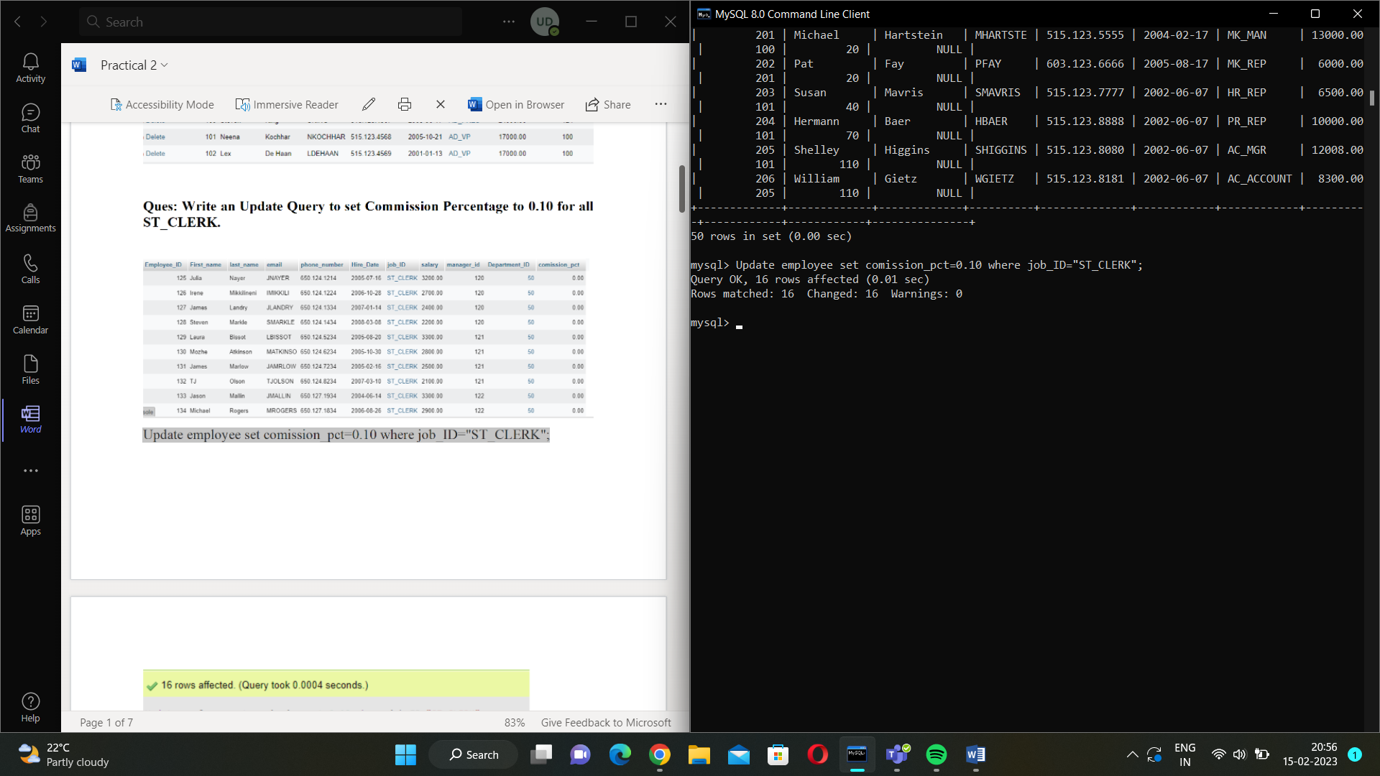

**Write an Update query to set Commission Percentage to 0.05 for rest of the Employee.**

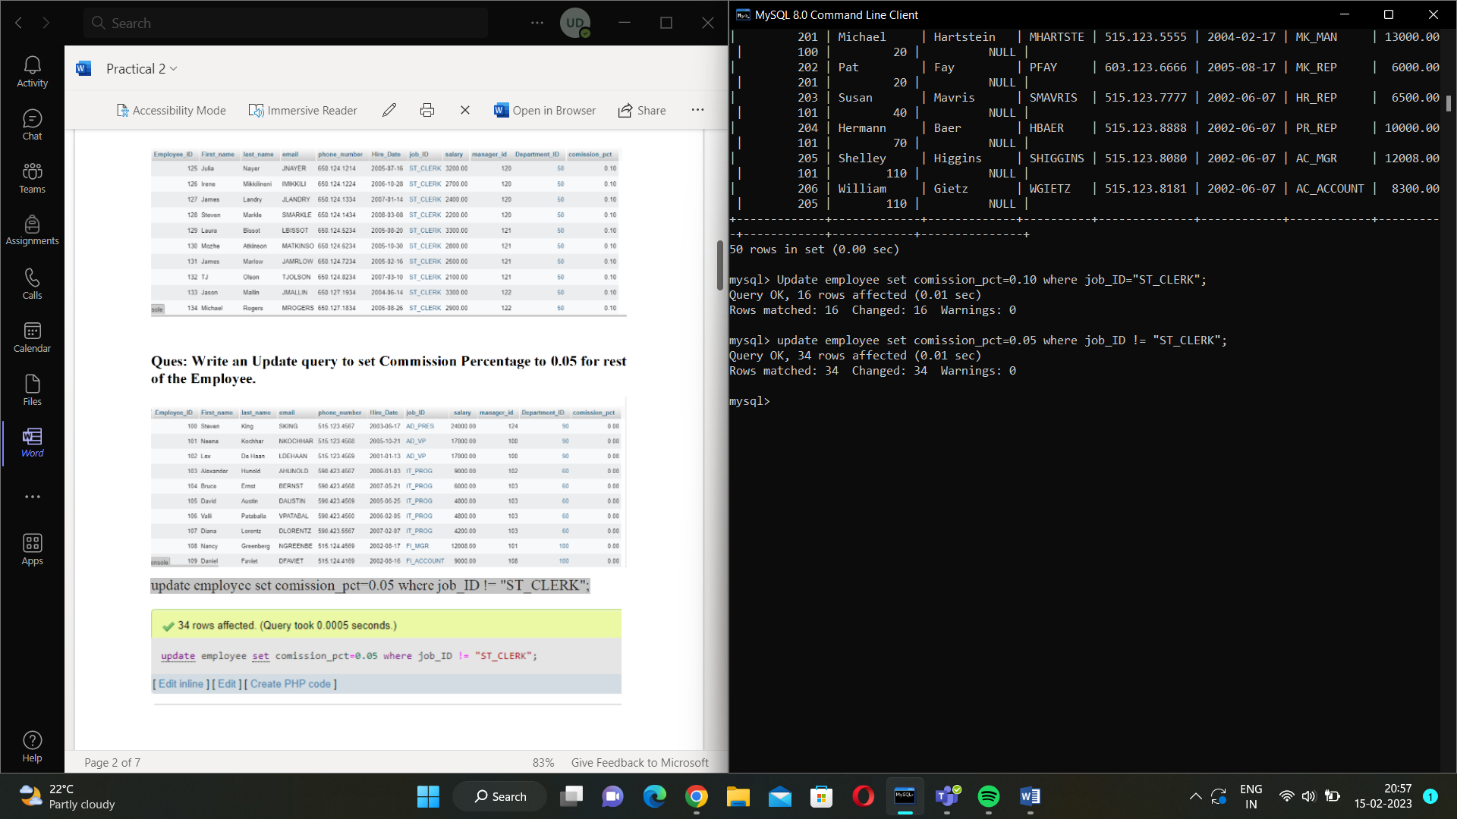

**Write an Update query to give increment of 10% in the salaries of all employees joined before 01-01-2006.**

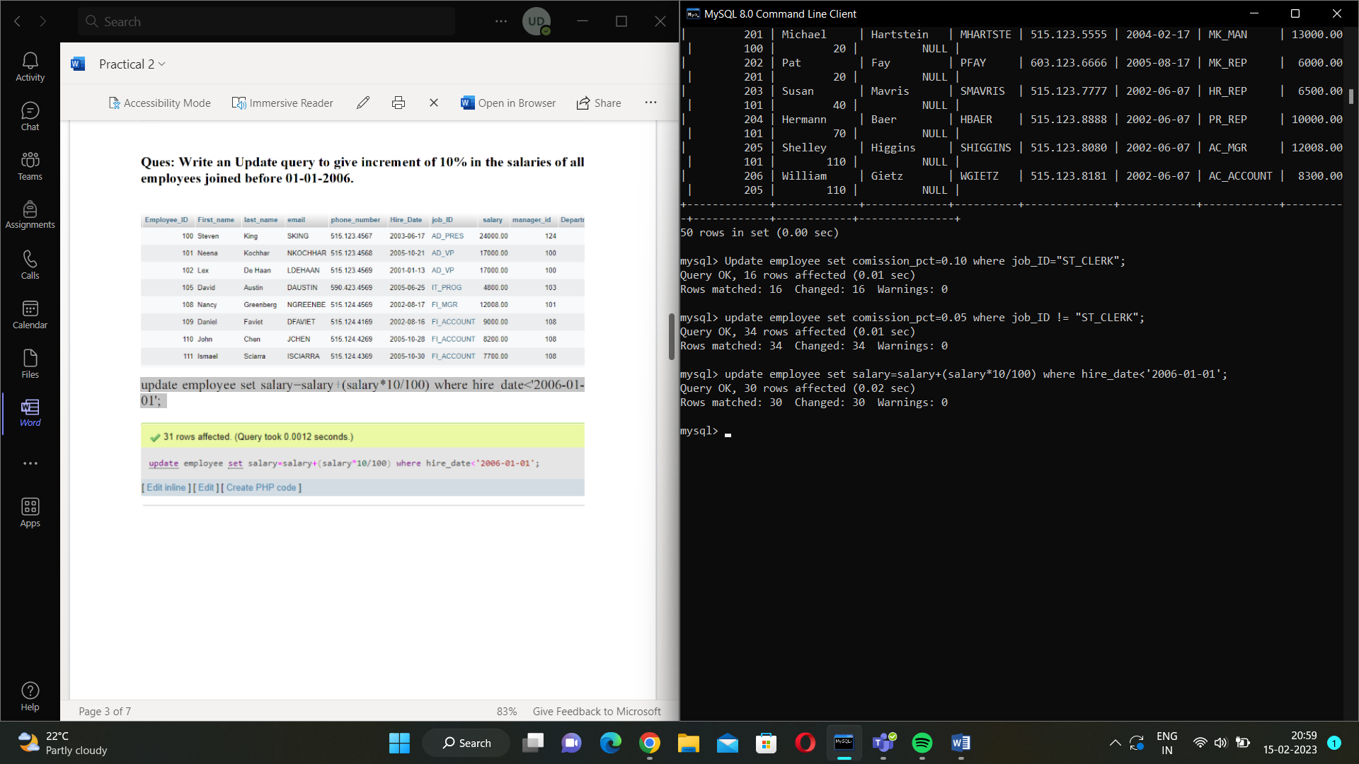

**Write an Update Query to change the department of Employee David Employee ID 105 to FI Department.**

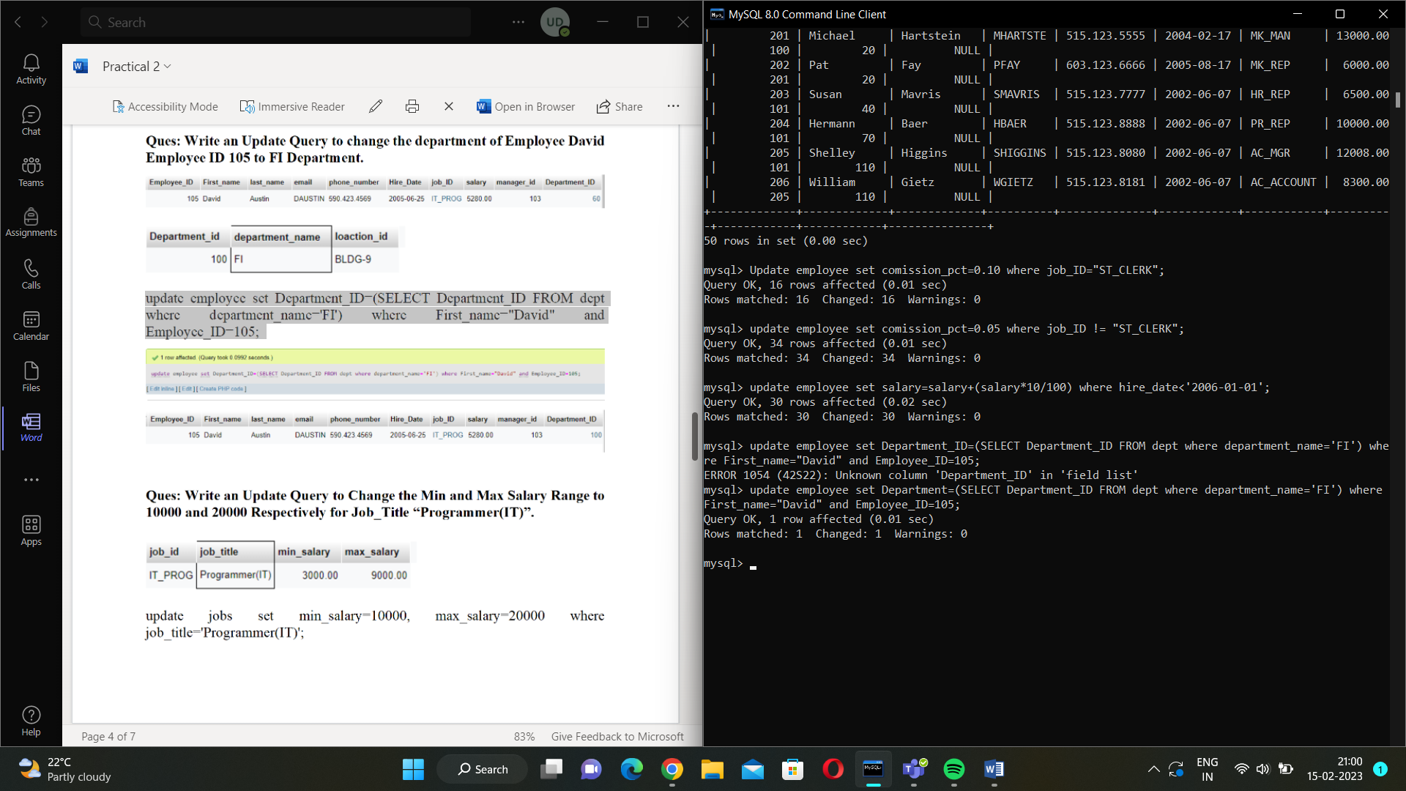

**Write an Update Query to Change the Min and Max Salary Range to 10000 and 20000 Respectively for Job_Title “Programmer(IT)”.**

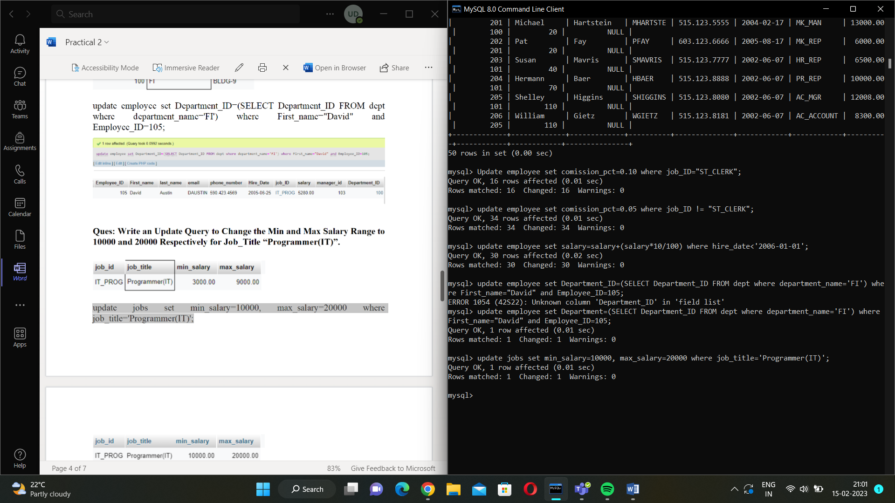

**Write a Delete query to delete all ST_CLERK whose salary is below 2000$.**

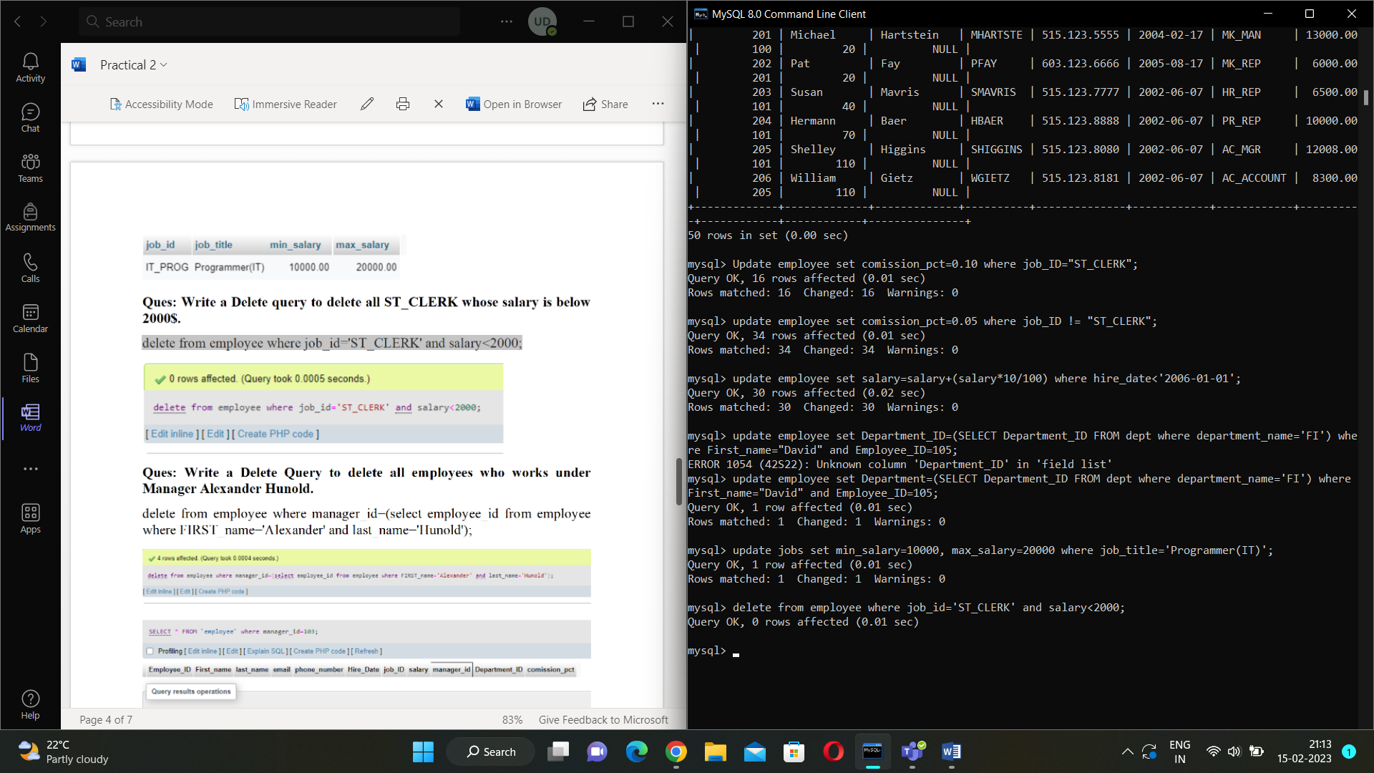

**Write a delete query to remove department PR and all the employees working under that department from the database.**

